Oak Ridge Place Standards

The Homeowners Association (HOA) has established standards to preserve the value of our homes and provide a safe and enjoyable experience for all residents. Some come directly from our Covenants, others have been established by our Board of Directors, all are monitored by our Standards Committee (“the Committee”). They fall within three areas:

Design Review. The Committee will review and approve any changes to the exterior appearance of homes. Section 3.02 of our Covenants:
No construction of a Residential Unit, or nor any other improvement … shall be commenced, executed, installed or maintained upon the Property until the plans and specifications showing the nature, kind, shape, height, materials, color and location of the same shall have been submitted to and approved in writing by the Association so as to preserve harmony of exterior design and location in relation to surrounding structures and topography.
Please submit an Architectural Change Application to receive approval.

Home Maintenance. Section 9.01 of our Covenants:
Each Residential Owner, by acceptance of his deed, covenants with all other Residential Owners by keeping his Residential Unit in a good state of maintenance and repair including without limitation: painting and caulking thereof at such intervals as shall be prudent, repair or replace all building material on the exterior of such Residential Unit as the need arises due to ordinary wear and tear, maintain and repair the grounds and landscaping of the Residential Unit.
Walkarounds are conducted periodically to ensure everyone is doing their part to keep the neighborhood looking good. Homeowners will be notified of items needing correction.

Practices. Section 3.09 of our Covenants:
No noxious or offensive activity shall be carried on upon any Residential Unit, nor shall anything be done thereon which may be or become an annoyance or nuisance as determined by the Association.
We’ve established reasonable standards for things like parking, trash, and yard debris removal. Please comply.

The following are our detailed standards for the general principles above:

Antennas, Satellite Dishes

Exterior television antennae and other electronic equipment shall be permitted only to the extent permitted by regulations adopted by the Association from time to time … (Covenants Section 3.08)

The term “Antenna” includes any direct broadcast system (DBS) satellite dish or wireless cable antenna system (MDS or MMDS) and any component of or addition to such antenna, including, without limitation, poles, masts, brackets, cables, or wiring. Antennas larger than one meter (39.37 inches) are not permitted. A notice of installation and documentation of the size, location and color of Antenna is required. Antennas must be installed within the boundaries of the owner’s lot and may not be installed on common area or adjacent lots. The Committee must review antennas location. The criteria for location approval are reception ability and screening from view. If placed on the ground or a pole, a proper landscape screen is required.

Awnings

It is not anticipated that awnings will be generally approved.

Bulk Waste

Homeowners will follow Town of Summerville limits on the types of items permitted, place items only on their own property (not in common areas), and place items not earlier than the Saturday before the scheduled pick-up date.

Clothes Lines

Laundry, bedding and the like shall not be hung out to dry in any position in which it is visible from the exterior of any Residential Unit. (Covenants Section 3.07)

Clotheslines or similar apparatus for the exterior drying of clothes will not be permitted.

Doghouses and Dog Runs

No animals of any kind shall be kept or maintained within any Residential Unit, except for such birds, dogs, cats, ornamental fish and other household pets as may be permitted by regulations adopted by the Association from time to time. In any event all pets, while outside a Residential Unit, shall be kept on a leash or other proper restraint, and shall at all times while outside be accompanied by the Owner or the Owner's agent (Covenants Section 3.06).

Doghouses and dog runs are prohibited. A dog run is defined as any fenced or walled structure (other than privacy fencing) constructed to allow dogs or other animals to exercise or otherwise move about portions of the owner’s property without escaping, or any other constraining device such as a post and leash which allows an animal to roam unattended beyond the boundaries of the owner’s property.

Exterior Air Conditioners

Individual air conditioning units extending from windows are prohibited. Exterior air conditioning units or heat pumps may be relocated or added only if there is no adverse visual impact to adjoining properties.

Exterior Colors

There shall be no change in any exterior color of any Residential Unit from color scheme then in effect throughout the Property, except in connection with a general change in such color scheme under the direction or with the approval of the Association. (Covenants Section 3.04)

The Association directs the transition of door and shutter color from Storm Gray to Charleston Green:
- Effective immediately [11/13/2021]: Homeowners may paint doors and shutters Charleston Green.
- Effective June 1, 2022: Homeowners painting doors and shutters must use Charleston Green. (Touchup of scratches with Storm Gray permitted.)
- Effective June 1, 2027: Homeowners must paint doors and shutters Charleston Green.

Exterior Decorative Objects

Approval will be required for all exterior decorative objects, whether natural or manmade, which were not part of the original construction design, either as a standard or optional feature. Examples include birdhouses, bird baths, driftwood, weathervanes, sculptures, fountains, free standing poles of all types, house identification numbers, and items attached to approved structures. These will be evaluated in terms of their general appropriateness, size, location, compatibility with the architectural and environmental design qualities and visual impact on the neighborhood and the surrounding area.

Exterior Lighting (General)

Lighting which illuminates either common areas or private property other than that on which it is installed, including reflected “backwash” behind houses, is prohibited. Proposed lighting shall not be approved if it will otherwise result in adverse visual impact on any other property, due to factors including but not limited to location, color, or wattage. As the effects of proposed lighting may be difficult to assess prior to installation, the HOA reserves the power to require correction, including but not limited to removal or modification of lighting found to cause adverse impact after installation.

Exterior Lighting (Attached)

Changes to the fixtures installed at the front and rear entrances of homes and the front and side entrances of the garage and installation of new attached lights require approval of the Committee. They will be painted black or Charleston Green and maintain a clean, professional appearance. They may acquire a natural patina. The style and scale will remain consistent with the original design but need not be identical. No neon or colored lights are permitted, and the illumination level should be as originally designed. Fixtures must remain in good working order.

Exterior Lighting (Detached)

Lighting installation requires approval of the Committee. Applications must include location, number, style, bulb color, and wattage. Recommended fixtures include low voltage ground-mounted styles that may be wholly or partially concealed by plantings. Lighting must improve footing, navigation or security, rather than being solely or primarily decorative and must be compatible in style and scale with the home. Colored bulbs designed to repel insects may be installed only in lighting fixtures located at the rear of houses.

Fences and Walls

It is not anticipated that fences or outbuildings will generally be approved. Any fence constructed along Gahagan Road must include an opaque landscape buffer, such as trees or shrubs, between the fence and the road.

Grilling

No charcoal- or gas-fired grill, fryer, or smoker shall be used in a screen porch or garage or within three feet of a structure, or within a greater limit recommended by the manufacturer. These devices may be stored there in accordance with the manufacturer’s recommendations.

Groundfeeding

Groundfeeding of wildlife is prohibited throughout the community, as “noxious or offensive activity” on Residential Units (Covenants Section 3.09) and under the authority of the Board of Directors to govern “the operation and use of the common properties” in our common areas (Bylaws Article IV, Section 2.4). The fine shall be $100 per offense plus any associated fees or costs, payable by the homeowner. Enforcement will be carried out only upon receipt by the President of the Association of date-marked photographic or video evidence (e.g. cell phone pictures or videos) identifying a violator.

Landscape

Front and side yards are to be landscaped. Major revision to existing landscaping including any change to existing grading, is subject to HOA review. No living tree with a diameter of 6 inches around at the height of four and one-half feet (4 ½’) may be cut removed without approval from the Committee. Owners should consider lot size and potential growth when choosing new shrubs/trees. Examples of trees/shrubs suitable for small lots and with non-invasive characteristics are listed on the last page.

Mailboxes, Mailbox Posts and Newspaper Tubes

Mailboxes will remain in their original locations. Mailboxes may be replaced only with units similar in size and style to those installed by the builder and may not be altered by applying non-standard letters or numbers. Mailbox numbers must be on the front of boxes. Mailboxes and mailbox posts will be black. Posts may be of the original H-style, a T-style for two units, or two single posts. Posts may be of any durable material approved by the Committee. Posts will be installed with concrete footings when replaced. The addition of tubes or other containers for delivery of newspapers is prohibited.

Maintenance of Property

Each Residential Owner, by acceptance of his deed, covenants with all other Residential Owners by keeping his Residential Unit in a good state of maintenance and repair including without limitation: painting and caulking thereof at such intervals as shail be prudent, repair or replace all building material on the exterior of such Residential Unit as the need arises due to ordinary wear and tear, maintain and repair the grounds and landscaping of the Residential Unit. (Covenant Section 9.01)

Property ownership includes the responsibility for continued maintenance of all structures and grounds, which are part of the owner’s lot. This includes, but is not limited to, keeping buildings and structures in good condition and repair, removing all debris and unsightly material, and keeping shrubs, trees, grass and other plantings neatly trimmed, properly cultivated, and free of weeds. Owners will not allow trees, shrubs, or plantings of any kind to overhang or otherwise encroach upon any street, pedestrian way, other owner’s property, or common area. In addition, owners will not alter any common area or easements. Such alterations include but are not limited to storing personal property, allowing debris to accumulate, establishing gardens, or otherwise adding, removing, or modifying trees or other plantings.

Outdoor Seating

Any seating to include all tables, umbrellas, benches, chairs, lounges, and swings placed overnight outside residences shall be of construction and materials intended for outdoor use and shall be placed on patios or within plant beds to permit uninhibited performance of routine landscaping services. Tables and umbrellas will be limited to patios only.

Patios and Decks

“Patios” are surface-level installations, “decks” are any raised installations, however low. The Town of Summerville would likely consider any deck as a “structure” and impose a five-foot setback from the property line.

Patios and decks may be constructed only in back yards, immediately adjacent to the home.

Width (depth into backyard): No patio or deck will cover any portion of an installed drainage system. The maximum width is 10 feet. The minimum width is 8 feet.

Patios may be constructed of poured concrete, stonework, stamped concrete. Decks will be constructed of PVC material (e.g. AZEK).

Where required, (minimum six feet high, maximum eight feet high) privacy fences (vinyl, color to match standard trim color) fences will be installed along the complete width. A fence will be installed on the side facing the adjoining home on any patio or deck which extends toward the adjoining home beyond the inside edge of the screen porch door. A fence will be installed on the side facing the adjacent home if the patio or deck extends beyond the outside edge of the screen porch door. No fence is required if the adjoining/adjacent home already has one within one foot of the property line. Any installed fence will be entirely on the property of, and will be the responsibility of, one homeowner.

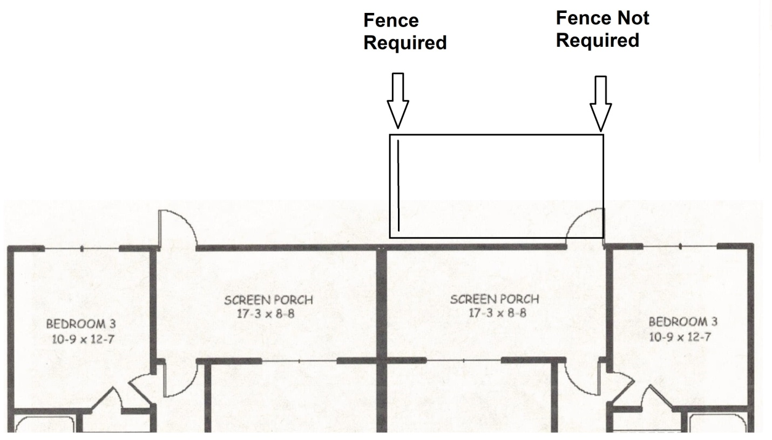

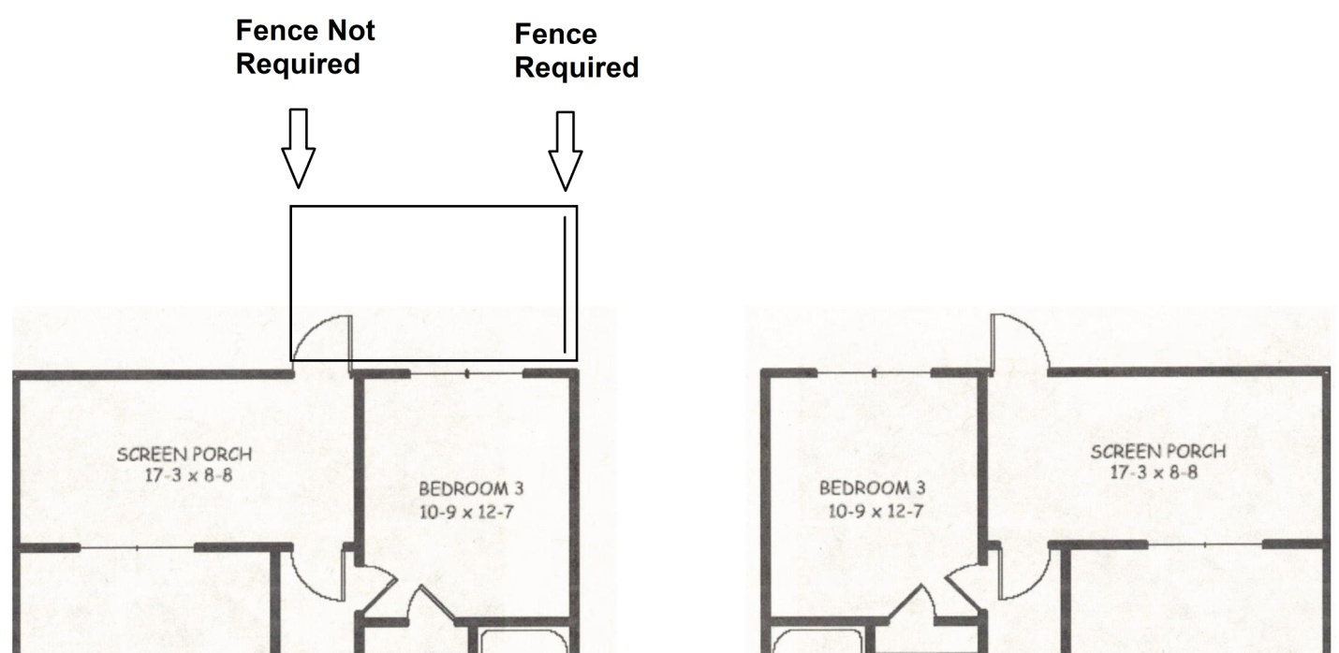

Additional fencing (vinyl, color to match standard trim color) may be added around the perimeter of the patio or deck, including the back of the patio or deck, at the discretion of the homeowner.

Note: There is a prohibition on awnings. (See “Awnings.”)

Guidelines on outdoor furniture and other items will be enforced on any patios or decks visible to other homes.

Recreation and Play Equipment

Semi-permanent play equipment, which either constitutes a structure or is appurtenant to an existing structure, requires approval. Examples include sandboxes, playhouses, swing-set, etc. Such equipment must be located in rear yards. The equipment should be generally compatible with the lot size. Backboards must be supported by freestanding or permanently installed post and located in the rear yard.

Security Bars

In general, the use of security bars or grates on windows and doors will be prohibited.
Homeowners concerned about the security of their homes are advised to consider alternatives, including alarms and sophisticated lock systems.

Side Plant Bed Options

Homeowners may opt to replace pine straw as the cover material for the plant beds on the side (not front or back) of their homes with mulch, or replace those beds with grass, at their expense. The HOA will continue to provide twice annual pine straw application where it remains (Covenants Amdt 3, Section 5.07a). Maintenance of mulch is a homeowner responsibility. The HOA will assume responsibility for planted grass as part of routine landscaping services. Homeowners are advised to avoid disturbing the soil near the foundation of their homes in order to preserve the effectiveness of termite treatments. Homeowners may, at their discretion and expense, place mesh under either pine straw or mulch to combat weeds.

Sidewalks and Pathways

Sidewalks and pathways should be set back at least four feet from the property line and installed flush to the ground. Only stone, brick, concrete, or similar durable construction material should be used. The scale, locations and design should be compatible with the lot, home and surroundings.

Signs

[N]o signs shall be placed on or within any Residential Unit (other than designations, in such styles and materials as the Association shall by regulation approve of street addresses and names of Residential owners) except that Residential Owners desiring to offer Residential units for rent or sale have the right to place upon the Residential Unit concerned such "for rent" or "for sale" signs as the Association may approve. (Covenants Section 3.05)

Only signs advertising a property for sale or rent may be displayed. Such signs must meet applicable County regulations with respect to size, content and removal. Signs may only be placed in the front yard of available properties.

Storage Sheds

In general, the installation of storage sheds will be prohibited.

Swimming Pools

Swimming pools are prohibited; both in-ground and aboveground.

Trash Containers

Trash and recyclable materials located outside residences will be kept only within the containers provided by the collection agency. Containers should be kept at the side of the home and placed at curbside no earlier than 5 p.m. before the day of regularly scheduled pick-up. Trash containers must be removed by 9 p.m. on day of pick up.

Vehicles and Parking

No vehicles, bicycles, carriages or other articles shall be outside the Residential Units except when in use and except for automobiles parked in areas designated therefore. (Covenants Section 3.07)
No trailer, truck or motorcycles except for personal pickups, boat, motor home, tent or shack may be erected or placed on any Residential Unit or street whether temporary or permanent. (Covenants Section 3.10)

Windows and Doors

Windows and doors for additions shall match those of the original dwelling or if the original windows are being replaced, all windows should be of the same sash color. The Committee must approve style of storm doors. Required style is clear glass top to bottom and white trim.

Wires and Cables

Wires and cables, including those installed to convey radio or television signals, shall be hidden, buried or secured flush with the side of each house so as to minimize their visibility.

Yard Debris

Homeowners will follow Town of Summerville limits on bagging, size, and content and will place debris only on their own property (not in common areas). The HOA itself may place debris generated in the common areas adjacent to 103 Manning Court and 133 Manning Court curbside in those common areas. Note: The Town’s “curbside” placement rule means placing debris either in the roadway, just next to the lawn, or on the lawn, just next to the roadway. Mechanized collection may result in scratching up your curb or minor damage to your lawn.
Examples of Trees/Shrubs

The following lists are not all-inclusive. Committee approval of siting is required even for recommended trees/shrubs.

Trees suitable for small lots that grow well in the South:

- Japanese Maple
- Crepe Myrtle
- Red Bud
- Oriental Magnolia
- Okame Cherry
- Taiwan Cherry
- Purple Leaved Plum

Trees with surface roots may interfere with the drainage system, driveways and foundations and may be uprooted in a severe storm. They will likely not be approved. These include:

- Maples
- Cottonwood
- Southern Magnolia
- Willow Oak
- Water Oak
- Bald Cypress

Trees that break easily during wind or ice storms may be approved, but are discouraged. These include:

- Bradford Pear
- River Birch
- Water Oak
- Pines
- Tulip Poplar

Shrubs that will not hide windows are encouraged. These include:

- Stoke Holly
- Dwarf Nandinas
- Crimson Pigmy Barberry
- Gumpo Azaleas
- Showy Jasmine
- Dwarf Indian Hawthorn

